**Functional Document**

|  |  |
| --- | --- |
| **Application** | NGERP – Centra |
| **Service Bundle** | Integeration |
| **Service Request** | Import Business Partner |

**Description:**

In Compiere (NGERP - Centra), the Import Business Partner Window is designed to facilitate the import of business partner data into the system. Once imported, business partner details can be viewed in the Manage Partner screen.

**Workflow Process:**

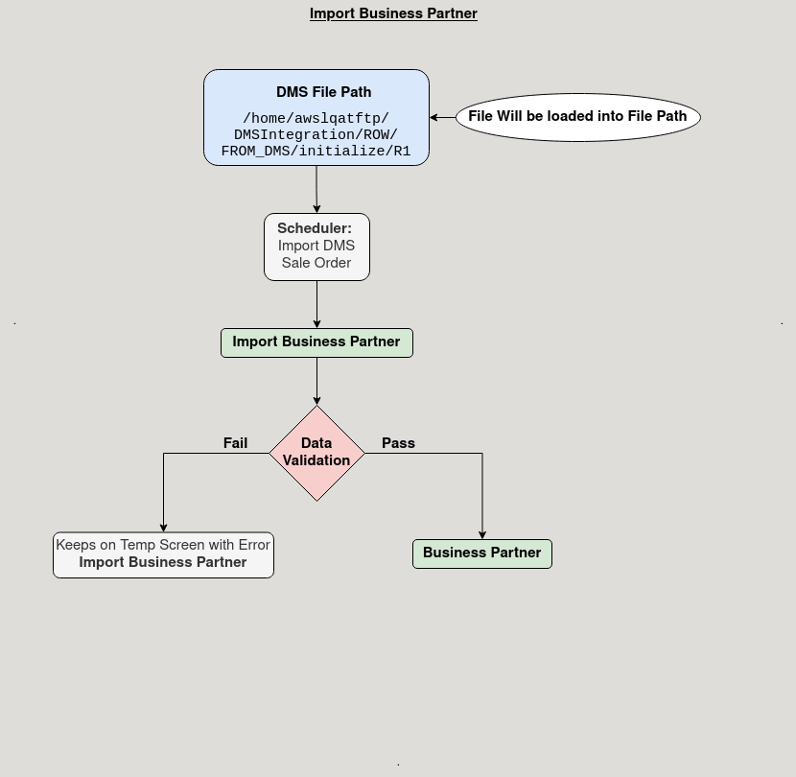

**Business Rules:**

* It is visible in both **ROW** and **HQOW.**
* The import template must include the following columns: Partner Search Key, Name, Name 2, Active, Contact (User), Location, GOA, 3A Channel, Sub Channel, Customer Program, Representative, Payment Method, Price List, Credit Limit, CL Approval Level 1, Payment Term, Tax ID.
* The import path for business partner data is /home/awslqatftp/DMSIntegration/ROW/FROM_DMS/initialize/R1.
* Importing DMS Partner with the respective organization ID in the last column of the (SYN_CUSTOMER) file. Importing DMS Partners without this ID should not be allowed.